# Power BI Assignment – 1

**• Install Power BI Desktop and share the final screenshot of the report view page which appears when power desktop starts.**

Installed Power BI Desk top and using free trial.

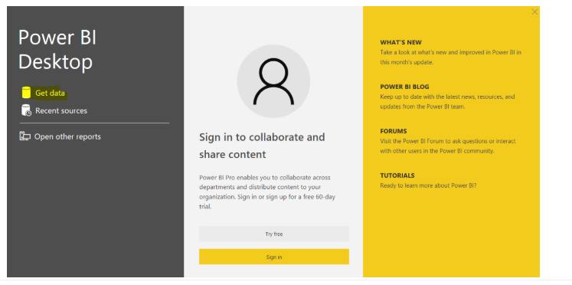

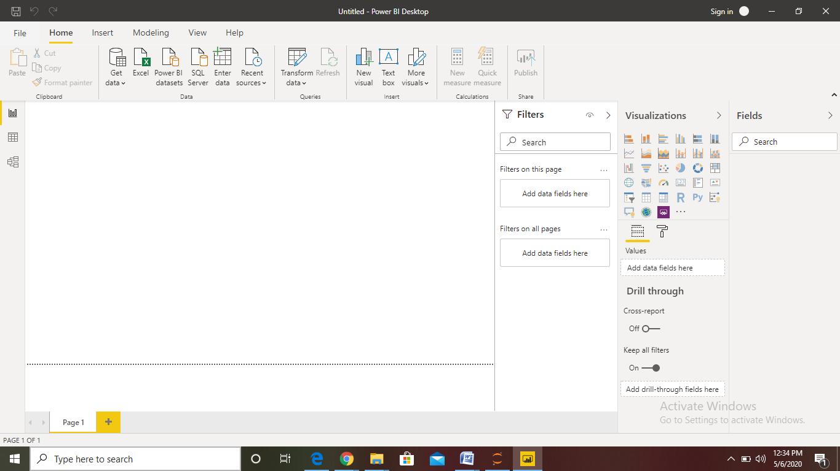

**• Prepare a document and with the following screenshot − Report View − Data View − Model View − Power Query Editor − Advance Editor**

**Report View:**

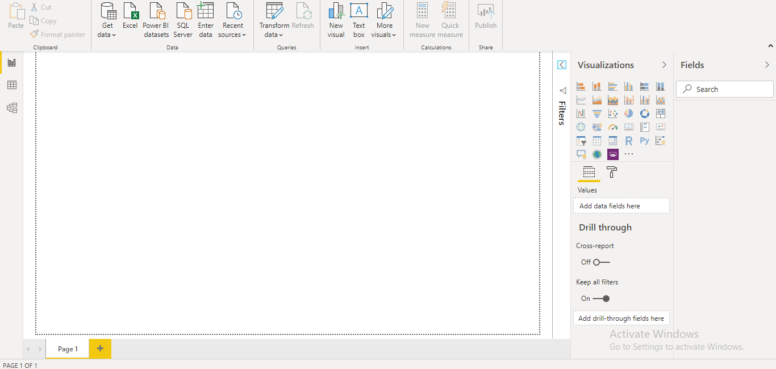

**Data View:**

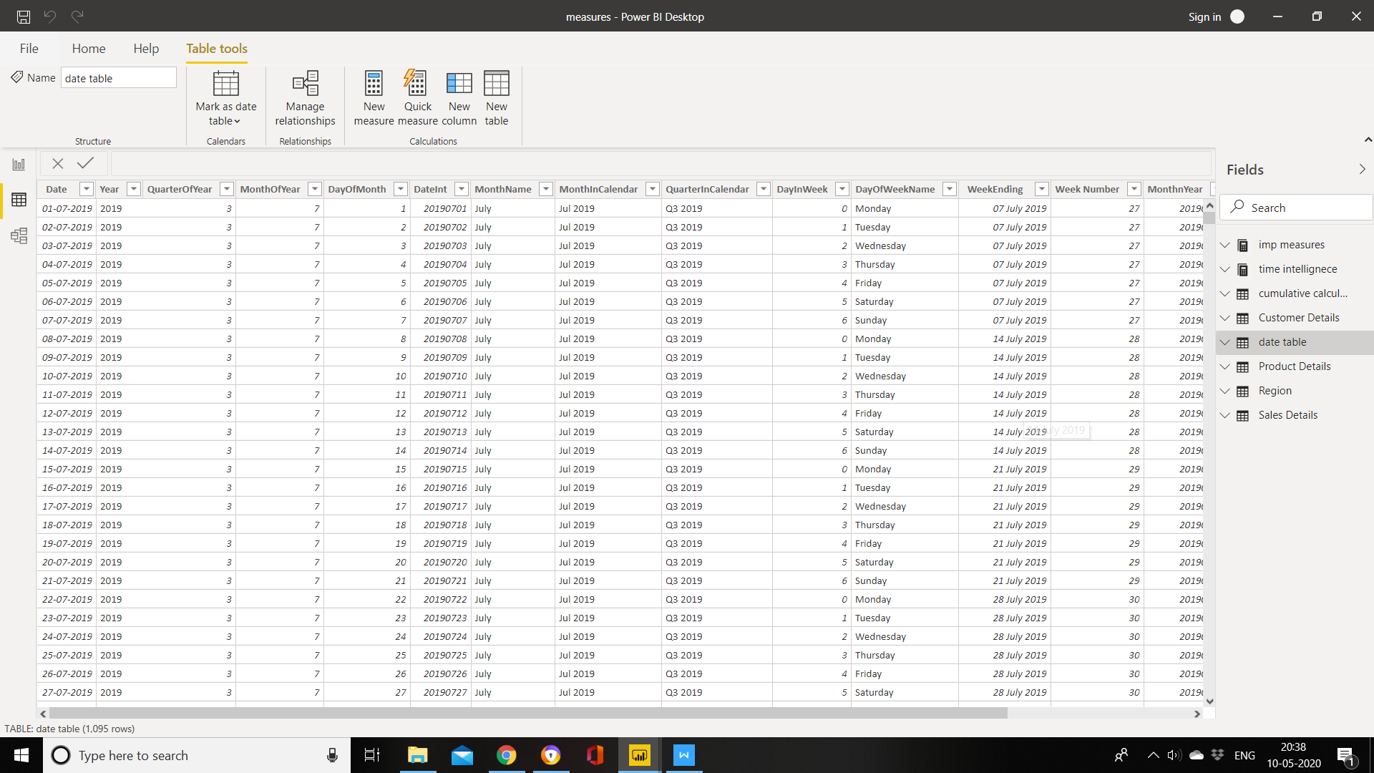

1. **Data view icon**. Select this icon to enter Data view.
2. **Data Grid**. This area shows the selected table and all columns and rows in it. Columns hidden from Report view are greyed out. You can right-click on a column for options.
3. **Modeling ribbon**. Here you can manage relationships, create calculations, change data type, format, data category for a column.
4. **Formula bar**. Enter Data Analysis Expression (DAX) formulas for Measures and Calculated columns.
5. **Search**. Search for a table or column in your model.
6. **Fields list**. Select a table or column to view in the data grid

**Model View :**

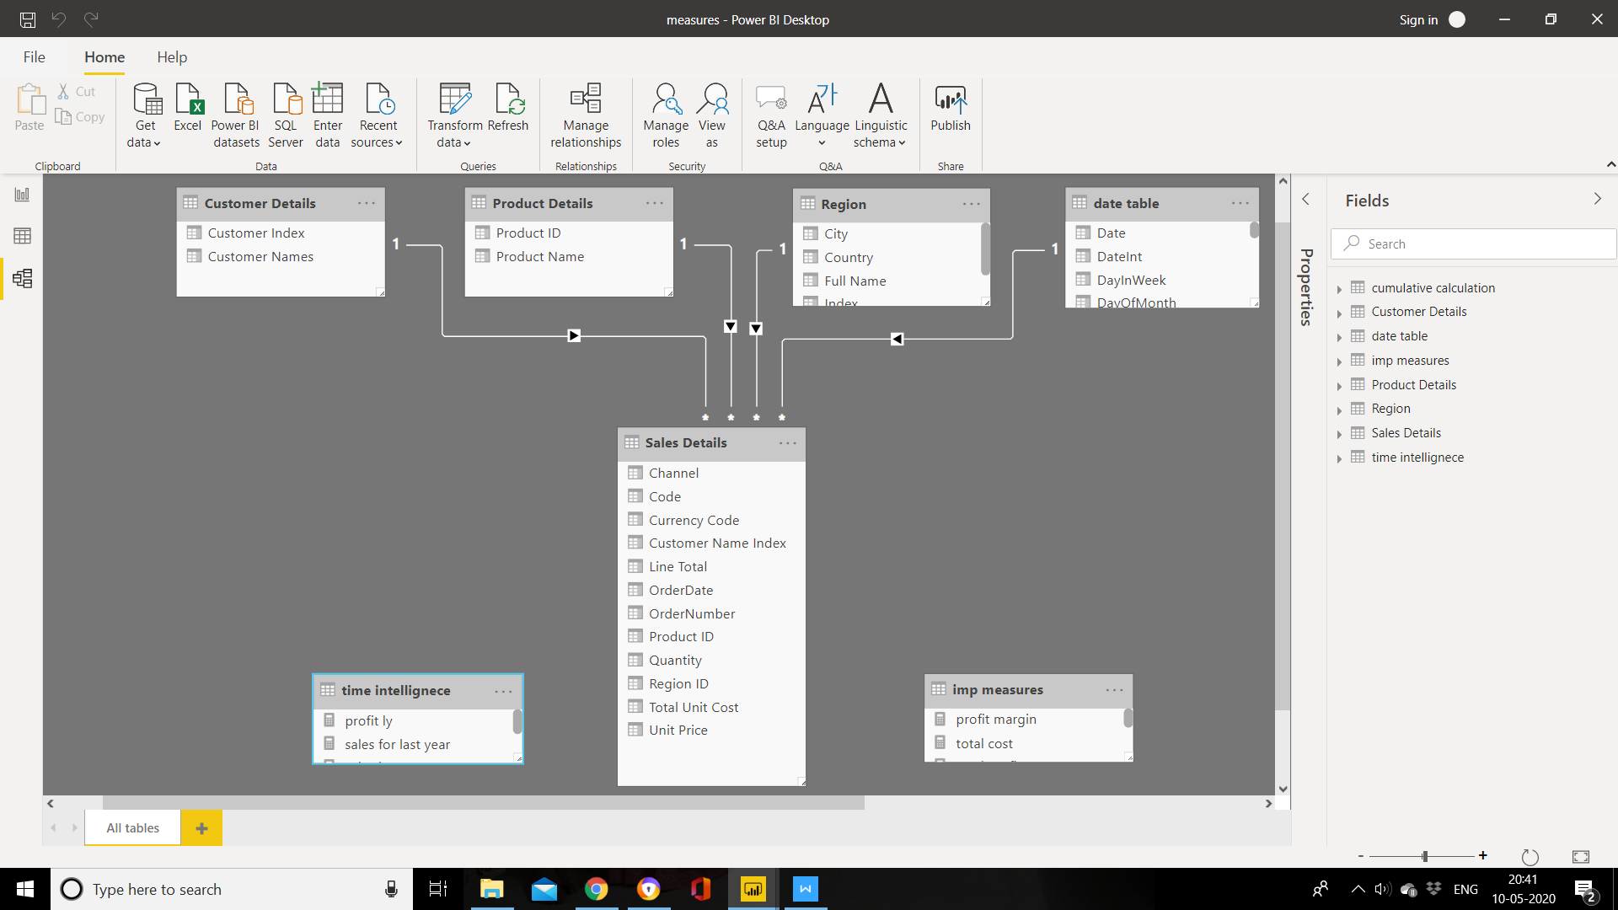

**Power Query Editor:**

Power BI Desktop also comes with Power Query Editor. Use Power Query Editor to connect to one or many data sources, shape and transform the data to meet your needs, then load that model into Power BI Desktop.

With no data connections, Power Query Editor appears as a blank pane, ready for data.

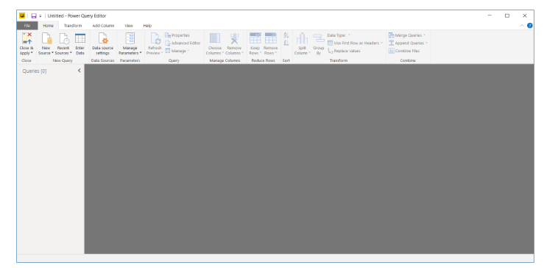

Once a query is loaded, Power Query Editor view becomes more interesting. If we connect to the following Web data source, Power Query Editor loads information about the data, which you can then begin to shape.

**Advanced Editor**

The **Advanced Editor** lets you see the code that Power Query Editor is creating with each step. It also lets you create your own shaping code. To launch the advanced editor, select **View** from the ribbon, then select **Advanced Editor**. A window appears, showing the existing query 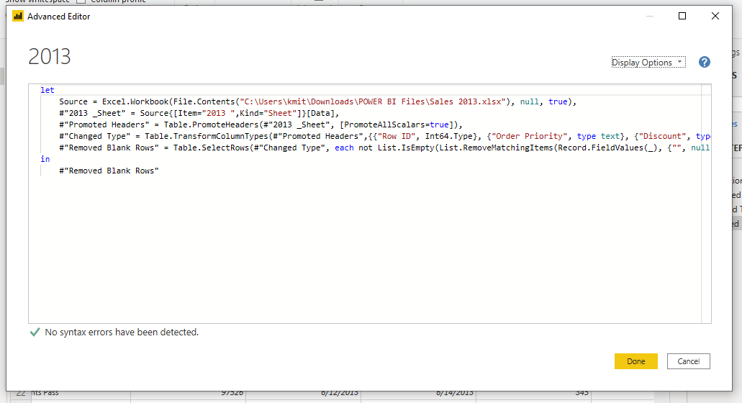

# • Prepare a document with details of the following along with their price − Power BI Desktop − Power BI Pro − Power BI Premium

Microsoft Power BI is a cloud-based business intelligence and analytics service that provides a full overview of your most critical data. Connecting to all of your data sources, Power BI simplifies data evaluation and sharing with scalable dashboards, interactive reports, embedded visuals and more.

Power BI has three pricing plans:

* **Power BI Desktop**: This offering is free to any single user and includes data cleaning and preparation, custom visualizations and the ability to publish to the Power BI service.
* **Power BI Pro**: The Pro plan costs $9.99/user/month. It includes data collaboration, data governance, building dashboards with a 360-degree real-time view and the ability to publish reports anywhere. Users can try it a free trial for 60 days before purchasing the subscription.
* **Power BI Premium:** The Premium plan starts at $4,995 a month per dedicated cloud compute and storage resource.